*Tyranids flood the battlefield with the psychic signature of the hive fleet, an icy, alien dread that gnaws at the minds of their prey and smothers even the most stalwart courage. When faced with such unfathomable horror, many are driven insane or suffer catastrophic neural damage.*

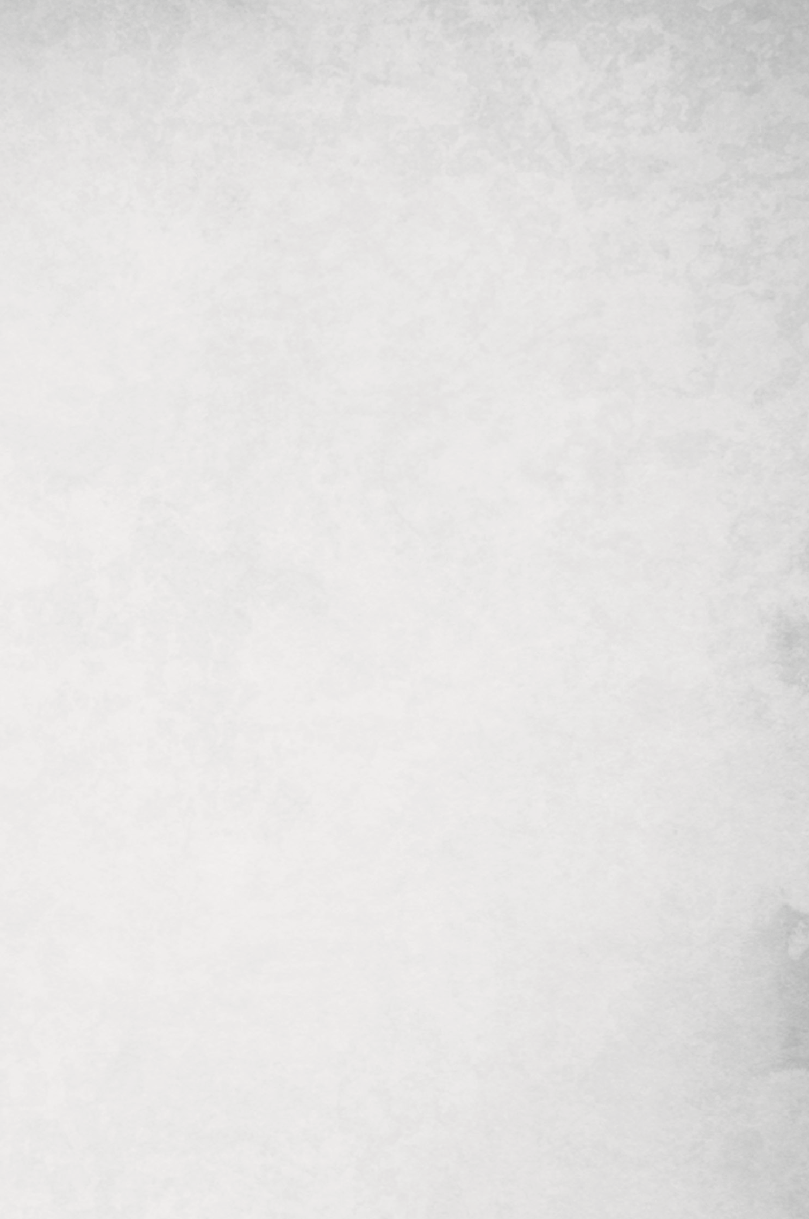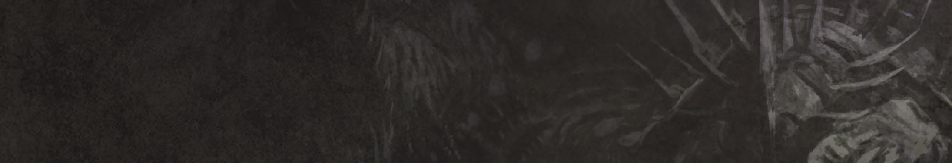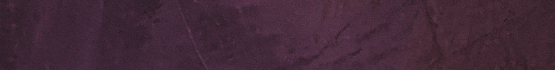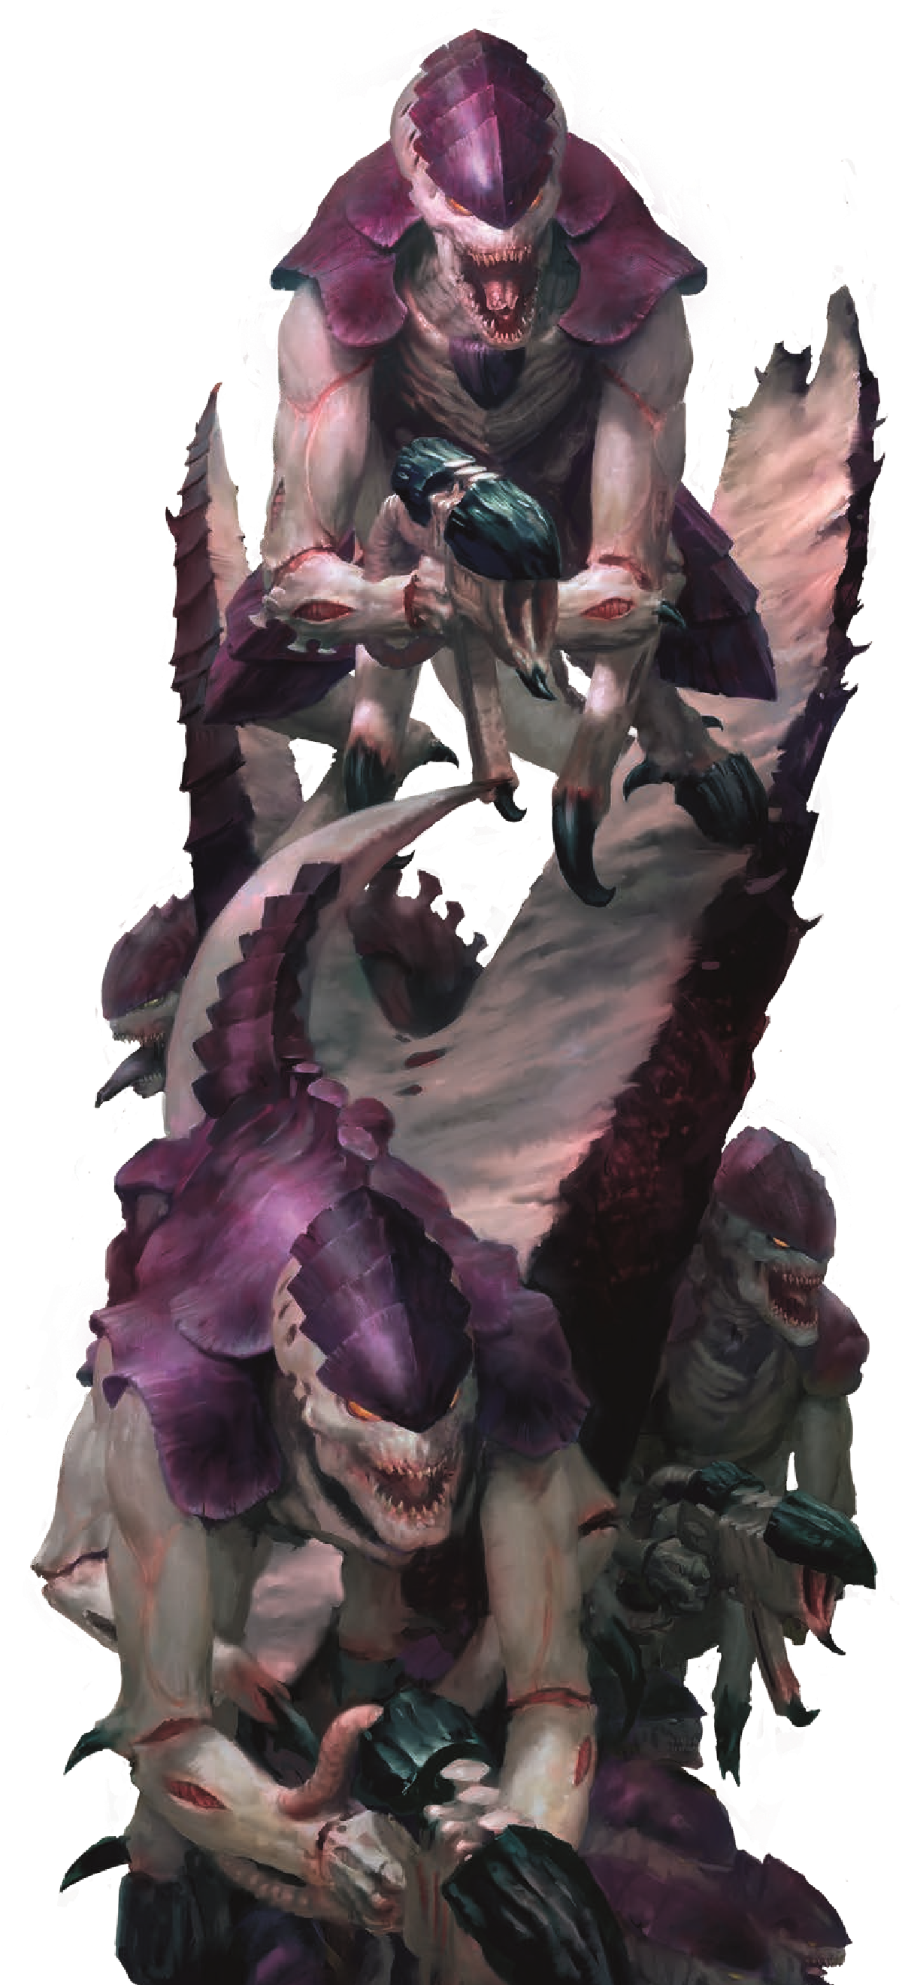

**TYRANIDS**

**ARMY RULES**

**SYNAPSE**

**SHADOW IN THE WARP**

If your Army Faction is **Tyranids**, once per battle, in either player’s Command phase, if one or more units from your army with this ability are on the battlefield, you can unleash the Shadow in the Warp. When you do, each enemy unit on the battlefield must take a Battle-shock test. If the enemy unit is within 6" of one or more **Synapse** models from your army, they take **-1** to this Battle-shock test.

If your Army Faction is **Tyranids**, while a **Tyranids** unit from your army is within 6" of one or more **Synapse** models from your army, that unit is said to be within Synapse Range of your army. Each time a **Tyranids** unit from your army takes a Battle-shock test, if it is within Synapse Range of your army, take that test on 3D6 instead of 2D6. The unit also gains **+1** to the **Strength** attribute of their attacks in melee.

*Some Tyranids serve as synaptic conduits or nodal relays through which a portion of the Hive Mind’s iron will flows, overriding the natural instincts of the swarm to direct the teeming warrior-beasts to function as a single, gestalt organism on the battlefield.*

If your Army Faction is **Tyranids**, you can use this Invasion Fleet Detachment rule.

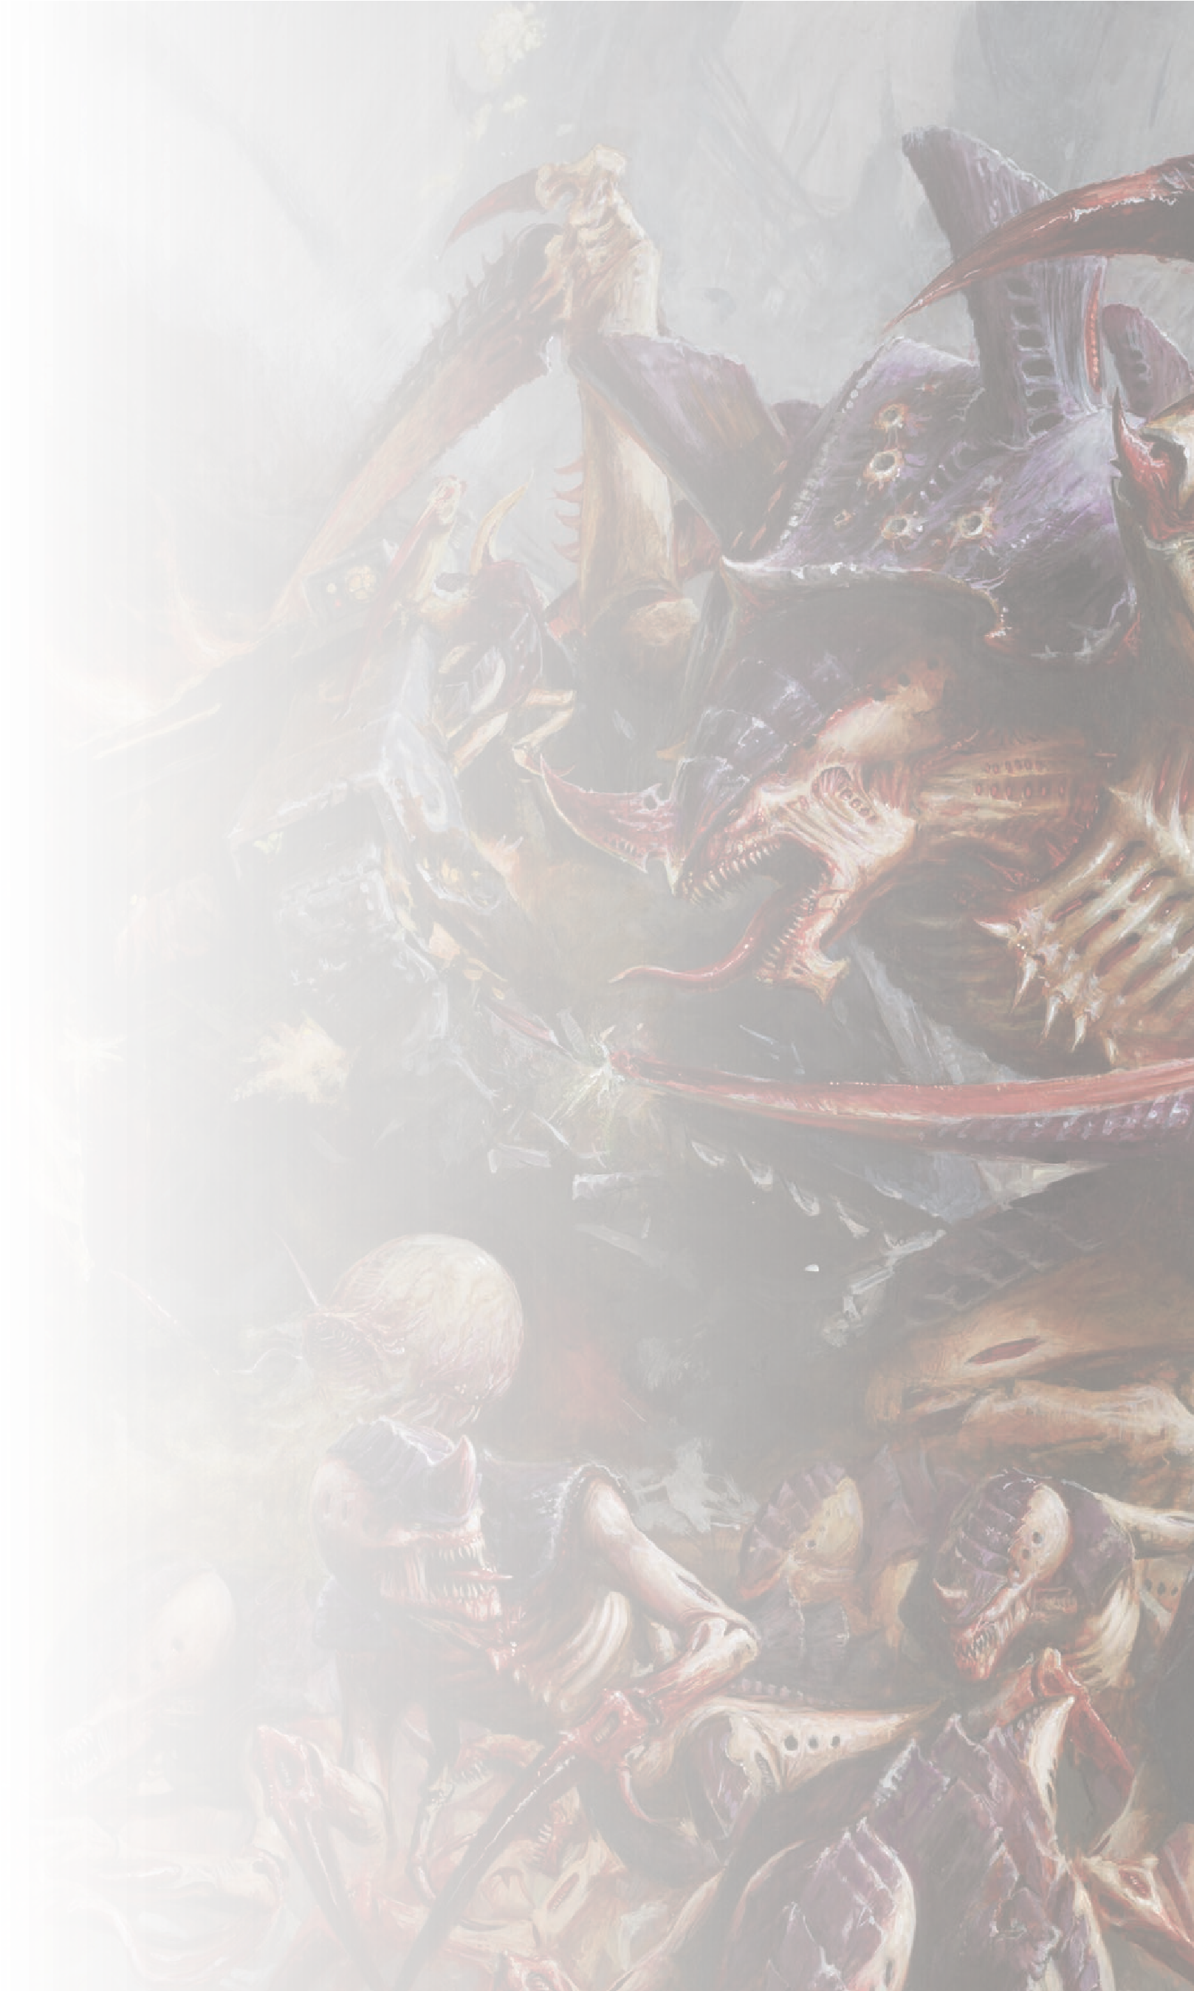

**TYRANIDS – INVASION FLEET**

**DETACHMENT RULE**

**HYPER-ADAPTATIONS**

*Every warrior organism in the Tyranid race is*

*fashioned by the ineffable alien will of the Hive Mind.*

*Their flesh and chitin is endlessly mutable, honed into*

*whatever form will prove most lethal to the prey.*

At the start of the first battle round, select one of the

following Hyper-adaptations to be active for

**Tyranids**

units from your army until the end of the battle:

**SWARMING INSTINCTS**

Each time a

**Tyranids**

model with this

Hyper-adaptation makes an attack that targets an

enemy

**Infantry**

or

**Swarm**

unit, that attack has the

**[**

**SUSTAINED HITS**

**1]**

ability.

**HYPER-AGGRESSION**

Each time a

**Tyranids**

model with this

Hyper-adaptation makes an attack that targets an

enemy

**Monster**

or

**Vehicle**

unit, that attack has the

**[**

**LETHAL HITS**

**]**

ability.

**HIVE PREDATORS**

Each time a

**Tyranids**

model with this

Hyper-adaptation makes an attack that targets an

enemy

**Character**

unit, if a Critical Hit is scored, that

attack has the

**[**

**PRECISION**

**]**

ability.

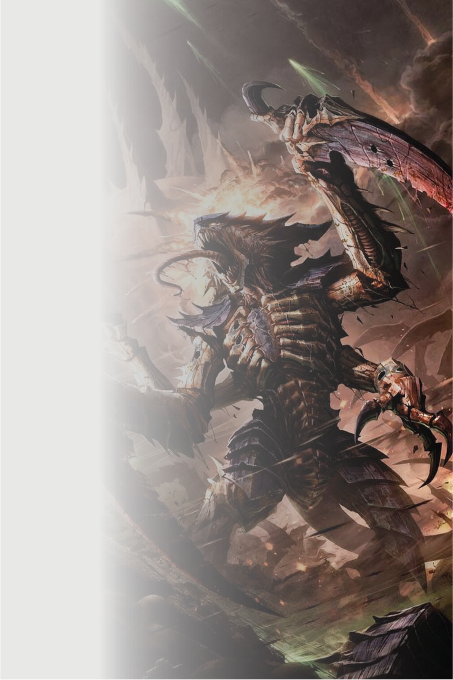

Each time a **Tyranids Monster** model from your army makes an attack, add 1 to the Hit roll if that model’s unit is below its Starting Strength, and add 1 to the Wound roll as well if that model’s unit is Below Half-strength. In addition, while a Tyranids Monster unit from your army (excluding Battle-shocked units) is at its Starting Strength, add 2 to the Objective Control characteristic of models in that unit.

*In their efforts to lay the monstrous beasts of a Crusher Stampede low, the prey only succeeds in further enraging the rampaging monsters. The surviving beasts are driven to fight with greater fury the more of their number that fall.*

**ENRAGED BEHEMOTHS**

If your Army Faction is **Tyranids**, you can use this Crusher Stampede Detachment rule.

**DETACHMENT RULE**

**TYRANIDS – CRUSHER STAMPEDE**